**Social Media Diary and Analysis**

**Part 1- Diary**

Social Network Site: Instagram

Post-Author: python.science

Time: Sep 15, 2022

Device Used: Phone.

Type of Interaction: Like.

Post Description: I have been following this account for the last year. I like the content they are posting here even in some posts they are sharing some good ideas for the python project. I like to learn some and also implement them. So basically, This Post is on the project traffic signal Violation detection system.

Additional Content:



Why did you interact?

I was looking for a python project in my previous semester so I search on Instagram and I got this account I like content and project ideas that why I followed and liked it.

**Part 2 – Analysis**

Here I am sharing my own social media activity.

This data is taken from my own phone device and the average time in the minute that I am spending every data on social media like Facebook, Instagram, and YouTube.

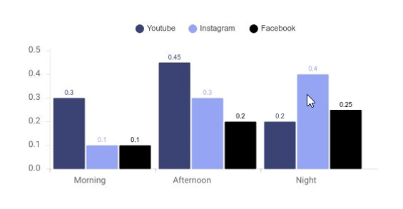

This I check my history of activity for the last 3 weeks based on three weeks that the average time(minute) I spend on these three platforms.

Most of my time l would like to watch memes I spend time on Instagram to what this.

As per my first part, I spend some time on Instagram to get some new ideas for a project to learn I spend some time on Instagram and then take one topic from Instagram I watch a video on YouTube related to this. Sometimes I spend time on YouTube watching news and short funny videos. Facebook I spent time on Facebook for the extra time for funny videos, news, and feeds to get something new.

So as per the graph, I spent more time on the social platform in the Afternoon and Night time.

I spent some time on LinkedIn for finding a job, and learn about new technology.

**Part 3 – An Ideal Post**

From the insights you gained about your social media interactions, you will describe an ideal post from a company/organization that would be most likely to gain a social

interaction from you. Your detailed description should include:

1) **The social network site on which the post will appear:** LinkedIn

2) **Name of company/organization making the post**: Saint Peter’s University

3) **Exact time of post:** Sep 12, 2022, 15:00

4) **Mock-up of the post including text, any visual content, and additional content such as hyperlinks or hashtags.**

This Post is about Sanit Peter’s University was recognized among the top ten best value institutions as 6th in the Regional Universities North category in 2023 as per [U.S. News & World Report](https://www.linkedin.com/company/us-news-and-world-report/) Best College Rankings. hashtags: [#BestColleges](https://www.linkedin.com/feed/hashtag/?keywords=bestcolleges&highlightedUpdateUrns=urn%3Ali%3Aactivity%3A6975133545417564160) they shared a link to their website. <https://bit.ly/3U1VYHF>



5) **Provide a short defense for why you would be likely to interact with the post. Use key insights from your social media analysis to support your defense.**

I am pursuing my Master’s in Data Science from the same saint peter’s University. So that is why I am following University on the LinkedIn platform. I can stay updated with my university’s news. I also feel proud that I am part of this institute

LinkedIn Platform that mostly I am using the stay updated with an organization that I want to join or that I am part of that organization. Also, for right, I am pursuing my master so I am using this for searching job.